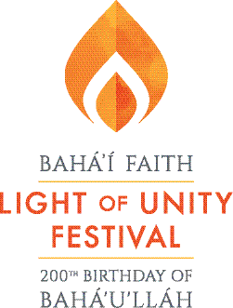

The Bahá’ís of Broward County are commemorating the 200th anniversary of the Birth of Bahá’u’lláh, the Founder of the Bahá’í Faith. You are invited to participate!

Who is Bahá’u’lláh?
Bahá’u’lláh (1817-1892) was a spiritual teacher who announced in 1863 that He was the bearer of a new revelation from God. His teachings have spread around the world, forming the basis of a process of social transformation and community building unique in its global scope and in the diversity of participants.
The “Light of Unity Festival” is a celebration of the transformative impact of Bahá’u’lláh’s teachings on the lives of families, neighborhoods and communities around the country and the world. Bahá’u’lláh’s vision of the oneness of humanity is an antidote to the racial prejudice and materialism that are corroding our society.

The Hidden Words of Bahá’u’lláh
…some excerpts

O SON OF SPIRIT! My first counsel is this: Possess a pure, kindly and radiant heart, that thine may be a sovereignty ancient, imperishable and everlasting.

O SON OF MAN! Veiled in My immemorial being and in the ancient eternity of My essence, I knew My love for thee; therefore I created thee, have engraved on thee Mine image and revealed to thee My beauty.

O SON OF BEING! Love Me, that I may love thee. If thou lovest Me not, My love can in no wise reach thee. Know this, O servant.

O SON OF BEING! Thou art My lamp and My light is in thee. Get thou from it thy radiance and seek none other than Me. For I have created thee rich and have bountifully shed My favor upon thee.

O SON OF MAN! For everything there is a sign. The sign of love is fortitude under My decree and patience under My trials.

PRAYER FOR UNITY

O my God! O my God! Unite the hearts of Thy servants, and reveal to them Thy great purpose. May they follow Thy commandments and abide in Thy law.
Help them, O God, in their endeavor, and grant them strength to serve Thee.
O God! Leave them not to themselves,
but guide their steps by the light of Thy knowledge, and cheer their hearts by Thy love. Verily, Thou art their Helper and their Lord. - Bahá'u'lláh

PRAYER FOR AMERICA

O Thou kind Lord! This gathering is turning to Thee. These hearts are radiant with Thy love. These minds and spirits are exhilarated by the message of Thy glad-tidings. O God! Let this American democracy become glorious in spiritual degrees even as it has aspired to material degrees, and render this just government victorious. Confirm this revered nation to upraise the standard of the oneness of humanity, to promulgate the Most Great Peace, to become thereby most glorious and praiseworthy among all the nations of the world. O God! This American nation is worthy of Thy favors and is deserving of Thy mercy. Make it precious and near to Thee through Thy bounty and bestowal. —‘Abdu’l-Bahá

Millions of members of the Bahá’í Faith -- in more than 100,000 localities in virtually every country and territory around the world -- form a global community. The Bahá’ís invite you to learn more about the teachings of Bahá’u’lláh, available from Bahai.org, or calling 800-22-UNITE.

For local information, please contact:

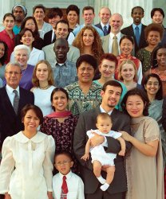

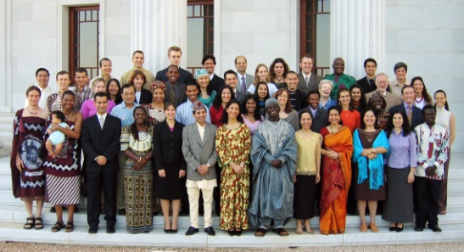

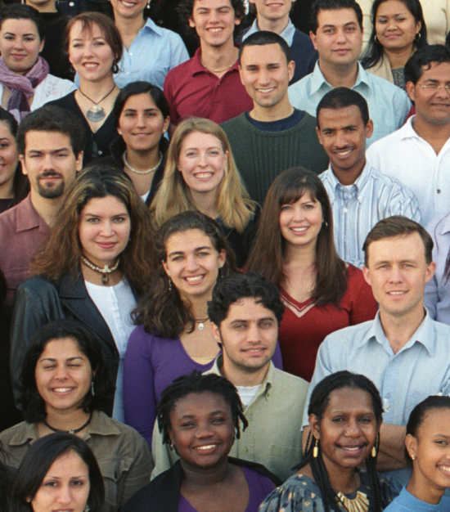

The Bahá'í Faith

Bahai.org 800-22-UNITE

“So powerful is the light of unity that it can envelop the whole earth.”

